Q.1 Write a program to read data from a CSV file and perform basic data cleaning operations like removing duplicates or handling missing values.

import pandas as pd

def clean_data(csv_file):

# Read the CSV file into a DataFrame

df = pd.read_csv(csv_file)

# Remove duplicate rows

df.drop_duplicates(inplace=True)

# Handling missing values

df.fillna(method='ffill', inplace=True) # Forward fill missing values

return df

if __name__ == "__main__":

# Path to the CSV file

csv_file = 'data.csv'

# Clean the data

cleaned_data = clean_data(csv_file)

# Display cleaned data

print("Cleaned Data:")

print(cleaned_data)

Data:

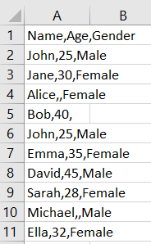

Result:

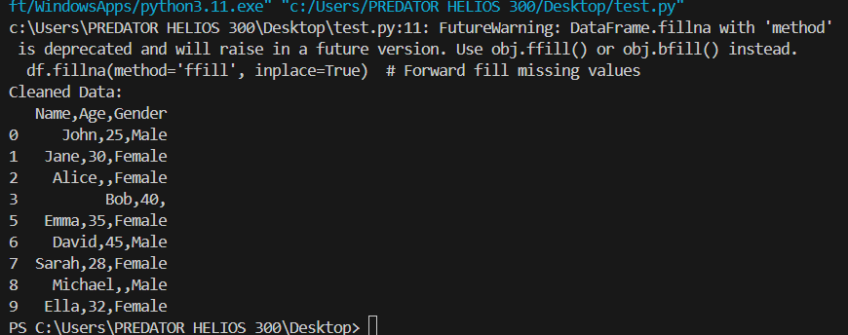

Q.2 Write a program to search for a specific pattern (e.g., email addresses or phone numbers) within a text file and extract them.

import re

def extract_emails(text):

# Define the regular expression pattern for email addresses

email_pattern = r'\b[A-Za-z0-9._%+-]+@[A-Za-z0-9.-]+\.[A-Z|a-z]{2,}\b'

# Use the findall() function to extract email addresses from the text

emails = re.findall(email_pattern, text)

return emails

if __name__ == "__main__":

# Open the text file

with open('test.txt', 'r') as file:

text = file.read()

# Extract emails from the text

extracted_emails = extract_emails(text)

# Display extracted emails

print("Extracted Emails:")

for email in extracted_emails:

print(email)

Text file:

* This is a sample text file containing some email addresses.
* You can contact me at john.doe@example.com or jane_smith123@gmail.com.
* Please don't hesitate to reach out to support@example.com if you have any questions.

Result:

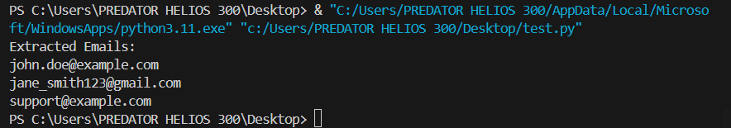

Q.3 Write a Python program to find the shortest path in a graph using Dijkstra's algorithm.

import heapq

def dijkstra(graph, start):

# Initialize distances to all vertices as infinity

distances = {vertex: float('infinity') for vertex in graph}

distances[start] = 0 # Distance from start vertex to itself is 0

# Initialize priority queue

priority_queue = [(0, start)] # (distance, vertex)

while priority_queue:

# Get the vertex with the smallest distance from the priority queue

current_distance, current_vertex = heapq.heappop(priority_queue)

# Check if current distance is larger than the stored distance

if current_distance > distances[current_vertex]:

continue

# Iterate through neighbors of the current vertex

for neighbor, weight in graph[current_vertex].items():

distance = current_distance + weight

# If new distance is smaller than stored distance, update it

if distance < distances[neighbor]:

distances[neighbor] = distance

heapq.heappush(priority_queue, (distance, neighbor))

return distances

if __name__ == "__main__":

# Example graph (dictionary of dictionaries)

graph = {

'A': {'B': 5, 'C': 3},

'B': {'A': 5, 'C': 2, 'D': 1},

'C': {'A': 3, 'B': 2, 'D': 4},

'D': {'B': 1, 'C': 4}

}

start_vertex = 'A'

shortest_distances = dijkstra(graph, start_vertex)

print("Shortest distances from vertex", start_vertex + ":")

for vertex, distance in shortest_distances.items():

print("Vertex:", vertex, "Distance:", distance)

Result:

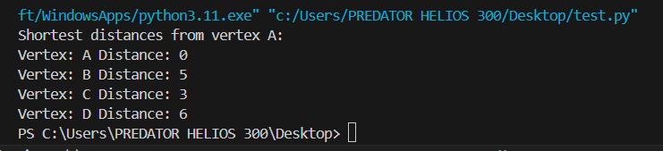

Q.4 Create a Python class to represent a bank account with methods for deposit, withdrawal, and checking the balance.

class BankAccount:

def __init__(self, account_holder, initial_balance=0):

self.account_holder = account_holder

self.balance = initial_balance

def deposit(self, amount):

if amount > 0:

self.balance += amount

print(f"Deposited {amount} units. Current balance: {self.balance}")

else:

print("Invalid amount for deposit.")

def withdraw(self, amount):

if 0 < amount <= self.balance:

self.balance -= amount

print(f"Withdrew {amount} units. Current balance: {self.balance}")

else:

print("Insufficient funds or invalid amount for withdrawal.")

def check_balance(self):

print(f"Current balance for account holder {self.account_holder}: {self.balance}")

# Example usage:

account1 = BankAccount("John Doe", 1000)

account1.deposit(500)

account1.withdraw(200)

account1.check_balance()

Result:

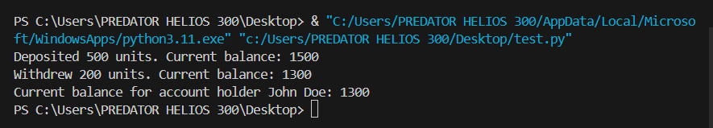

Q.5 Create a GUI-based file manager that allows users to browse directories, view files, and perform basic file operations like copy, move, and delete.

import os

import shutil

import tkinter as tk

from tkinter import filedialog, messagebox

class FileManagerApp:

def __init__(self, root):

self.root = root

self.root.title("File Manager")

self.current_path = tk.StringVar()

self.current_path.set(os.getcwd())

self.create_widgets()

def create_widgets(self):

self.path_label = tk.Label(self.root, textvariable=self.current_path)

self.path_label.pack()

self.file_listbox = tk.Listbox(self.root, width=50, height=20)

self.file_listbox.pack()

self.refresh_button = tk.Button(self.root, text="Refresh", command=self.refresh_files)

self.refresh_button.pack()

self.copy_button = tk.Button(self.root, text="Copy", command=self.copy_file)

self.copy_button.pack()

self.move_button = tk.Button(self.root, text="Move", command=self.move_file)

self.move_button.pack()

self.delete_button = tk.Button(self.root, text="Delete", command=self.delete_file)

self.delete_button.pack()

self.browse_button = tk.Button(self.root, text="Browse", command=self.browse_directory)

self.browse_button.pack()

self.refresh_files()

def browse_directory(self):

directory = filedialog.askdirectory()

if directory:

self.current_path.set(directory)

self.refresh_files()

def refresh_files(self):

self.file_listbox.delete(0, tk.END)

path = self.current_path.get()

for item in os.listdir(path):

self.file_listbox.insert(tk.END, item)

def get_selected_file(self):

selection = self.file_listbox.curselection()

if selection:

return self.file_listbox.get(selection[0])

else:

return None

def copy_file(self):

filename = self.get_selected_file()

if filename:

src = os.path.join(self.current_path.get(), filename)

dst = filedialog.asksaveasfilename(initialdir=os.getcwd(), initialfile=filename)

if dst:

shutil.copy2(src, dst)

messagebox.showinfo("Success", f"File '{filename}' copied successfully.")

def move_file(self):

filename = self.get_selected_file()

if filename:

src = os.path.join(self.current_path.get(), filename)

dst = filedialog.askdirectory()

if dst:

shutil.move(src, dst)

self.refresh_files()

messagebox.showinfo("Success", f"File '{filename}' moved successfully.")

def delete_file(self):

filename = self.get_selected_file()

if filename:

if messagebox.askyesno("Delete", f"Are you sure you want to delete '{filename}'?"):

path = os.path.join(self.current_path.get(), filename)

os.remove(path)

self.refresh_files()

messagebox.showinfo("Success", f"File '{filename}' deleted successfully.")

if __name__ == "__main__":

root = tk.Tk()

app = FileManagerApp(root)

root.mainloop()

Result:

